UNITED STATES

SECURITIES AND EXCHANGE COMMISSION
Washington, D.C. 20549

FORM 6-K

REPORT OF FOREIGN PRIVATE ISSUER

PURSUANT TO RULE 13a-16 OR 15d-16

UNDER THE SECURITIES EXCHANGE ACT OF 1934

April 8, 2020

Commission File Number: 001 - 38178

Zealand Pharma A/S

(Exact Name of Registrant as Specified in Its Charter)

Sydmarken 11

2860 Søborg (Copenhagen)

Denmark

(Address of principal executive offices)

Indicate by check mark whether the registrant files or will file annual reports under cover of Form 20-F or Form 40-F.

Form 20-F ☒ Form 40-F ☐

Indicate by check mark if the registrant is submitting the Form 6-K in paper as permitted by Regulation S-T Rule 101(b)(1): ☐

Indicate by check mark if the registrant is submitting the Form 6-K in paper as permitted by Regulation S-T Rule 101(b)(7): ☐

Furnished as Exhibit 99.1 to this Report on Form 6-K is a company announcement of Zealand Pharma A/S or the Company, dated April 8, 2020, confirming receipt of information on transactions in the Company’s shares or related securities by persons discharging managerial responsibilities and/or their closely associated persons.

SIGNATURE

Pursuant to the requirements of the Securities Exchange Act of 1934, the registrant has duly caused this report to be signed on its behalf by the undersigned, thereunto duly authorized.

Zealand Pharma A/S

By: /s/ Matthew Dallas

Name: Matthew Dallas

Title: Chief Financial Officer

Date: April 8, 2020

2

 |  | EXHIBIT INDEX
Exhibit
No. |  | Description
99.1 |  | Company announcement dated April 8, 2020
99.2 |  | Notification of sale of shares: A. Steensberg 2020Apr02
99.3 |  | Notification of sale of shares: A. Steensberg 2020Apr03
99.4 |  | Notification of sale of shares: A. Steensberg 2020Apr06
 |  | 3

Exhibit 99.1
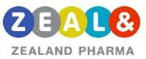

Company announcement – No. 18 / 2020

Transactions in Zealand Pharma shares and/or related securities by persons discharging managerial responsibilities and/or their closely associated persons

Copenhagen, April 8, 2020 – Zealand Pharma A/S (“Zealand”) (NASDAQ: ZEAL) (CVR-no. 20 04 50 78) has received information on transactions in Zealand's shares or related securities conducted by persons discharging managerial responsibilities and/or their closely associated persons and hereby publishes the information on such transactions.

Please see the attached files.

For further information, please contact:

Zealand Pharma Investor Relations

+45 50 60 38 00 investors@zealandpharma.com

Lani Pollworth Morvan, Investor Relations and Communication

lpm@zealandpharma.com

About Zealand Pharma A/S

Zealand Pharma A/S (Nasdaq Copenhagen and New York: ZEAL) ("Zealand") is a biotechnology company focused on the discovery and development of innovative peptide-based medicines. More than 10 drug candidates invented by Zealand have advanced into clinical development, of which two have reached the market. Zealand’s current pipeline of internal product candidates focus on specialty gastrointestinal and metabolic diseases. Zealand’s portfolio also includes clinical license collaboration with Boehringer Ingelheim and pre-clinical license collaboration with Alexion Pharmaceuticals.

Zealand is based in Copenhagen (Søborg), Denmark. For further information about the Company's business and activities, please visit www.zealandpharma.com or follow Zealand on LinkedIn or Twitter @ZealandPharma.

Exhibit 99.2
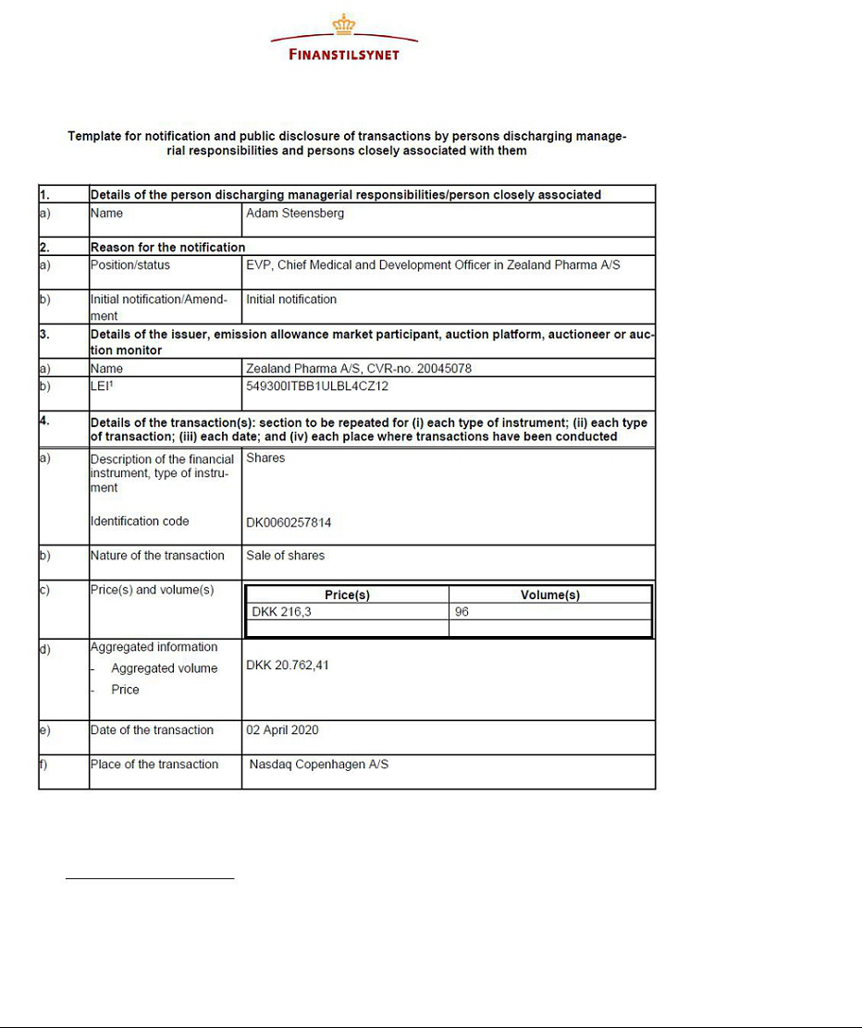

Exhibit 99.3
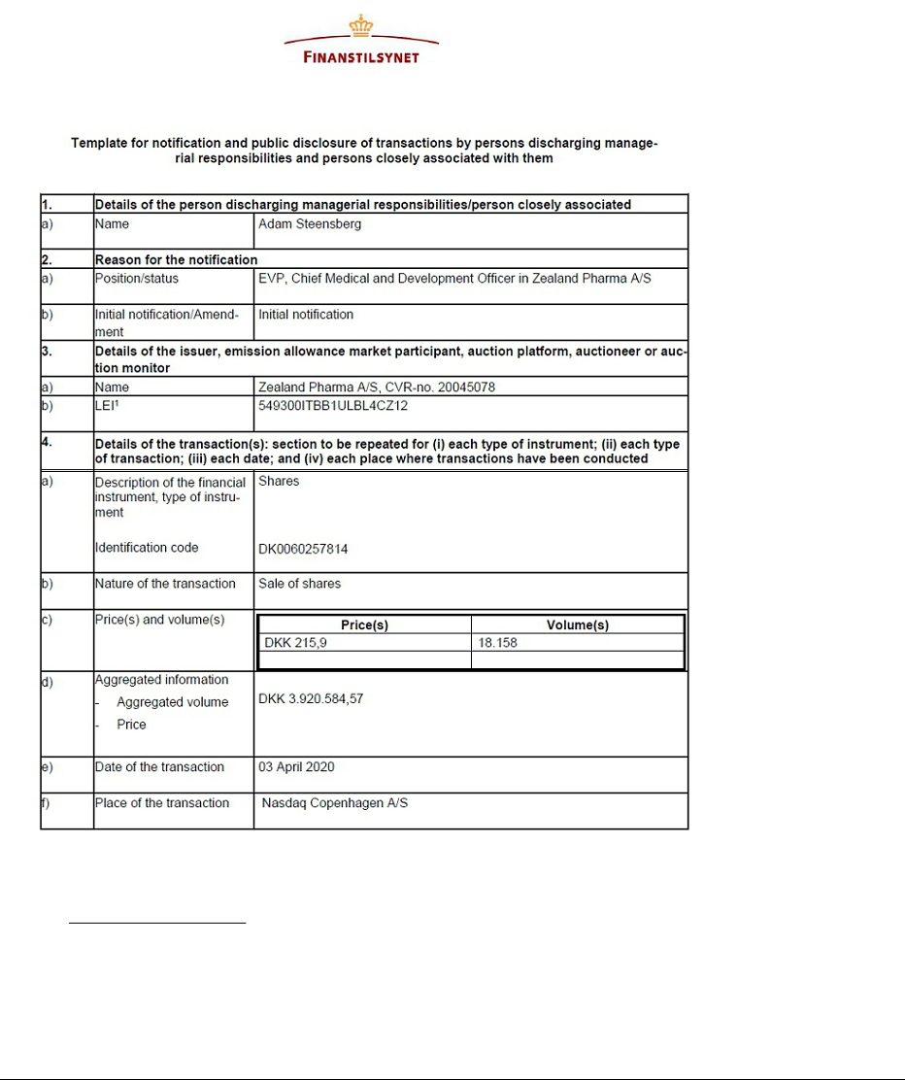

Exhibit 99.4


